Green Logistics – Proposed Solution
1. Our solution: Smart Green Logistics System
Build a modern website that analyzes delivery information and recommends more sustainable logistics operations.
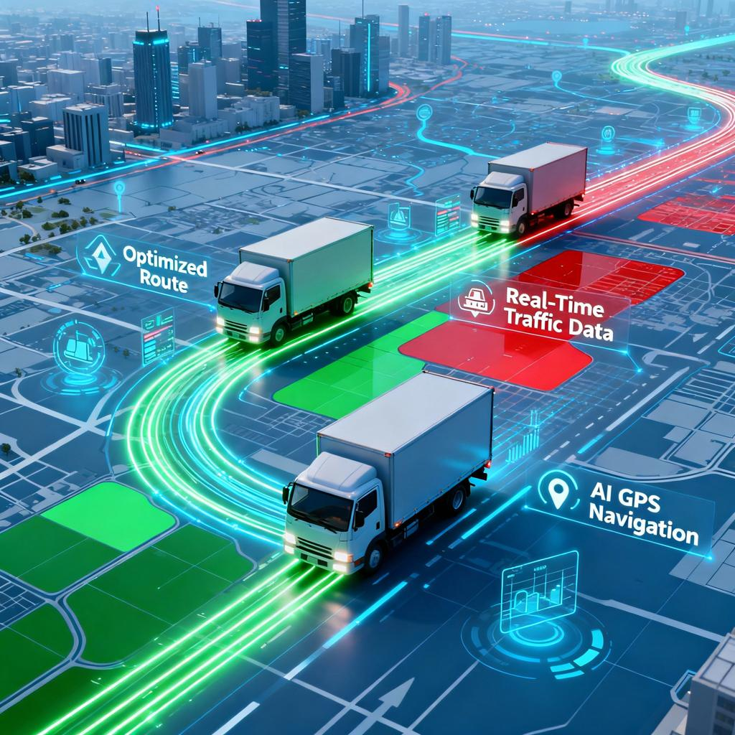
1. Smart Route Optimization
Find shorter, practical delivery routes to reduce unnecessary distance, travel time, and fuel consumption.
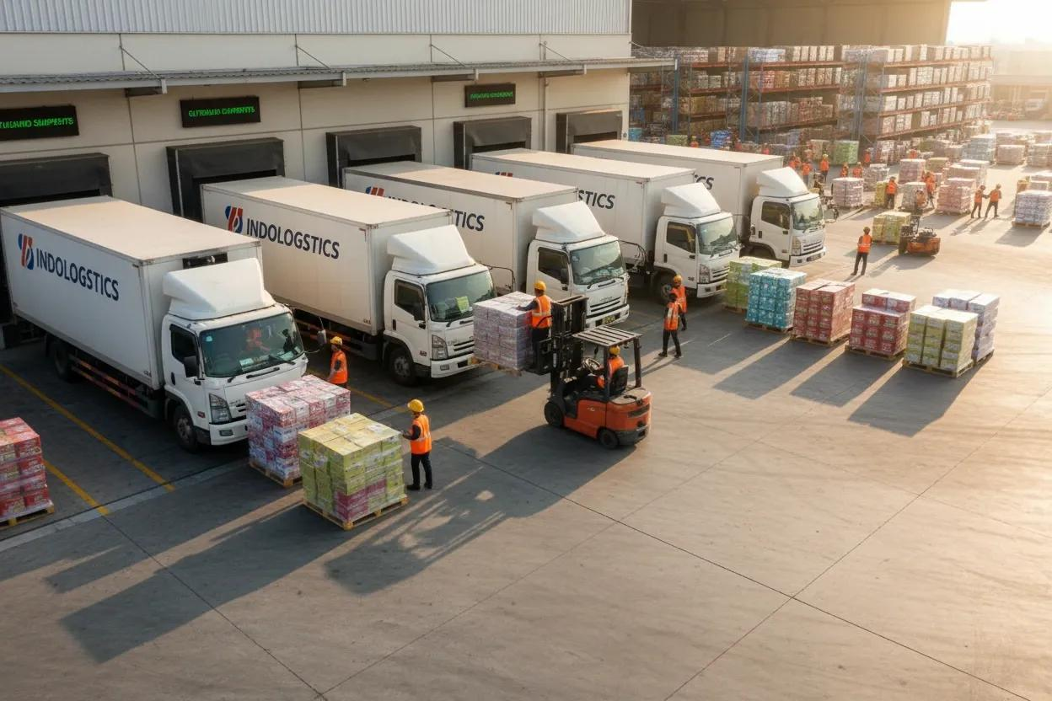
2. Vehicle Load Optimization
Check vehicle capacity and shipment weight. Recommend combining nearby deliveries or using a suitably sized vehicle.
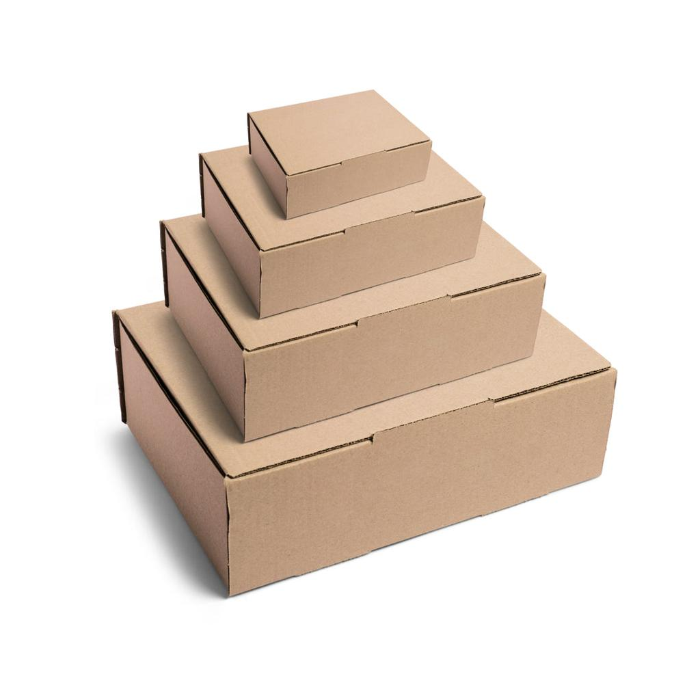
3. Eco-Friendly Packaging
Identify excessive packaging and recommend recyclable or right-sized packaging where suitable.
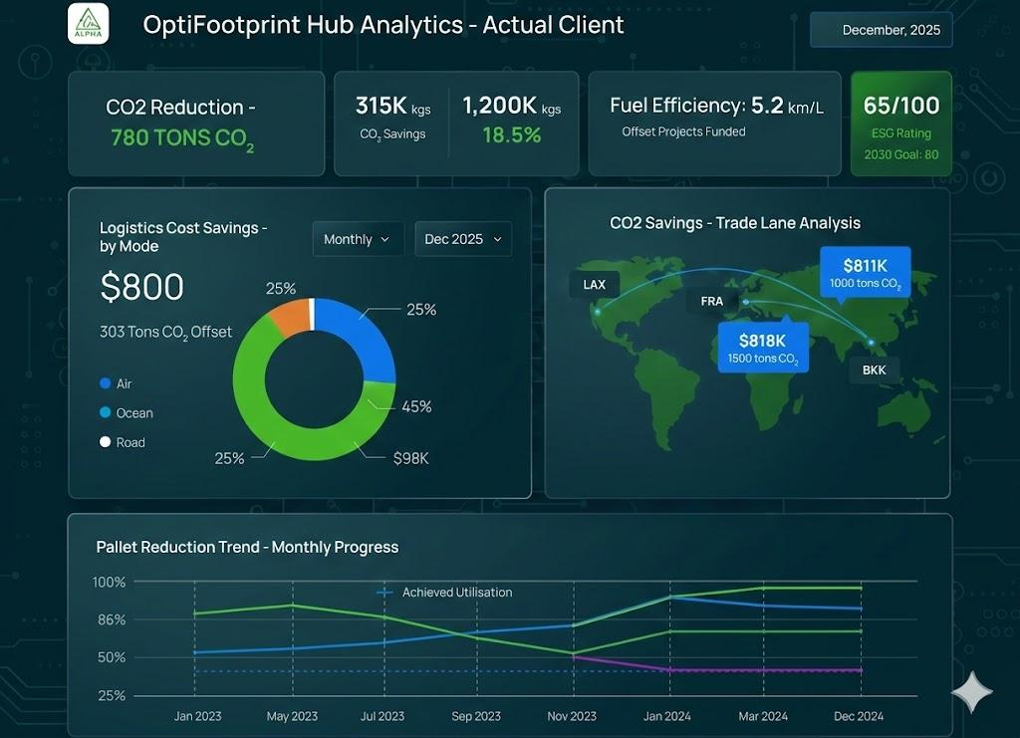
4. Green Analytics Dashboard
Display fuel consumption, estimated CO₂ emissions, distance travelled, vehicle utilization, and before-and-after comparisons.
2. How our website will work
Step 1: Upload logistics dataset
CSV or Excel file containing delivery, vehicle, fuel, distance and packaging details
Step 2: Clean and analyze data
Handle missing values, duplicates and invalid records
Step 3: Green optimization engine
Evaluate routes, vehicle capacity, repeated trips and packaging
Step 4: Generate recommendations
Suggest better routes, combined deliveries and suitable vehicles
Step 5: Show results
Compare existing and proposed logistics performance
3. Calculations required
These calculations will help prove that your solution works.
Metric | Calculation
Vehicle utilization | (Load ÷ Vehicle capacity) × 100
Fuel saved | Existing fuel − Proposed fuel
Fuel reduction % | (Fuel saved ÷ Existing fuel) × 100
CO₂ emissions | Fuel consumed × documented emission factor
Distance saved | Existing distance − Proposed distance
Distance reduction % | (Distance saved ÷ Existing distance) × 100
Example calculation
Suppose your illustrative demo uses the following figures. These are sample values, not measured results from your dataset.
Metric | Existing plan | Proposed plan
Distance | 200 km | 160 km
Fuel consumption | 40 L | 32 L
Vehicle capacity | 1,000 kg | 1,000 kg
Shipment load | 400 kg | 700 kg
- Distance reduction: 20%
- Fuel reduction: 20%
- Vehicle utilization: improves from 40% to 70%.
Calculate CO₂ emissions using a documented fuel emission factor. The final results must come from your actual dataset or clearly identified assumptions.
4. Website features to implement
01
Dashboard
Summary cards for fuel, CO₂ emissions, distance and green score.
02
Dataset Upload
Upload CSV/Excel files and validate their contents.
03
Route Analysis
Flag long routes, repeated trips and opportunities to combine nearby deliveries.
04
Vehicle Analysis
Show load utilization and recommend appropriate vehicle capacity.
05
Packaging Analysis
Identify high packaging usage and possible waste reduction.
06
Before vs After
Charts showing fuel, emissions, distance and cost changes.
07
Recommendations
Provide a reason and expected benefit for each suggested improvement.
08
Report Export
Download the analysis and assumptions for the final hackathon report.
5. Technology stack
- Frontend: HTML, CSS, JavaScript or React.
- Backend: Python with Flask or FastAPI.
- Data analysis: Pandas.
- Charts: Chart.js or Plotly.
- Dataset: CSV or Excel.
- Deployment: Run locally on your laptop, with clear setup instructions.
6. Green recommendation rules
Condition detected | Recommendation
Low vehicle utilization | Combine compatible nearby shipments.
Multiple deliveries in the same area | Plan a combined delivery route.
Excessive travel distance | Evaluate an alternative route.
Empty return journey | Find a suitable backhaul shipment.
Large vehicle carrying a small load | Consider a suitable smaller vehicle.
Excessive packaging | Use appropriately sized, recyclable packaging where feasible.
Urgent shipment | Preserve the required delivery time when evaluating consolidation.
7. What your team must submit
According to the problem statement, your final submission should include:
- Working Green Logistics website or application.
- Source code and processed dataset.
- Green optimization method.
- Fuel and CO₂ calculation.
- Before-and-after comparison.
- Green logistics recommendations.
- Sample inputs and outputs.
- Final presentation and REPORT.md.
- Assumptions, limitations and future improvements.
